SpecterX Outlook Connector – User & Installation Manual

Version & Data of Issue

Purpose: Provide admins & MSPs understanding of the capabilities and parameters of SpecterX Outlook Connector, installation guide, user manual and commonly issues in installation

Note:
- this needs a full review for validation of all content
  - Need distinction between Outlook Connector versus stand alone connector
- For internal use - need distinction between current capabilities and restrictions of this app versus our 365 app to be developed.

SpecterX SaaS Connectors

SpecterX SaaS Connectors are API integration modules designed by SpecterX to embed its platform within third-party applications, in this case Microsoft Outlook, enabling the application of security policies to data as it is exported or shared from managed environments. Connectors allow users to interface directly with SpecterX within applications for data sharing and exports.

SpecterX Outlook Connector

The SpecterX Outlook Connector is an add-in designed to seamlessly integrate SpecterX data-protection capabilities into Microsoft Outlook. By embedding SpecterX security controls directly into your familiar email workflow, the connector allows you to securely share files, apply protection policies, and manage access—all without leaving Outlook.
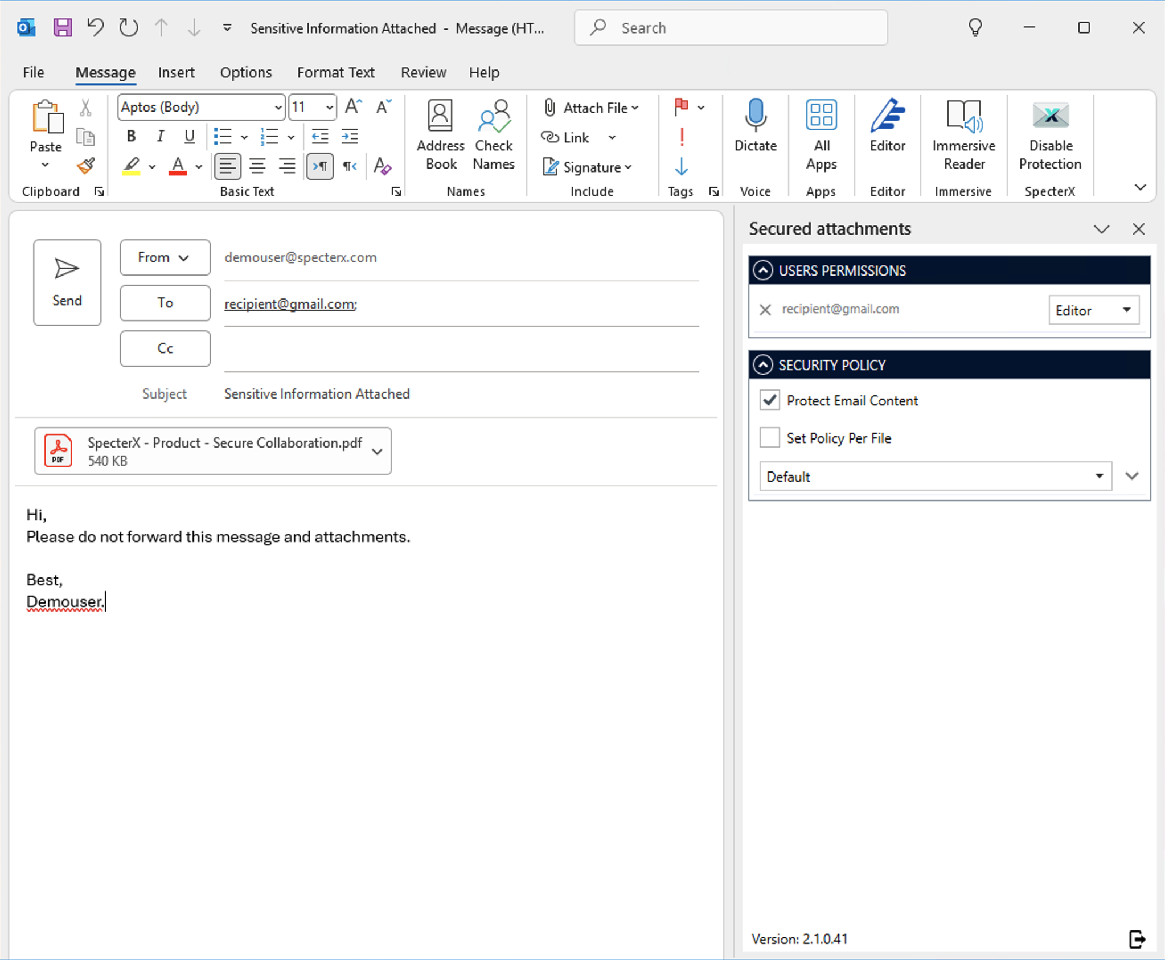

Install the SpecterX Outlook Add-in
As part of the onboarding process, you, as the administrator, will get from us the SpecterX Outlook Add-in (MSI file).
The add in installation is very simple, just double click the installer and follow the on-screen instructions.
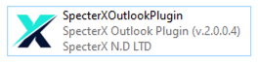

Once installed, you’ll notice a new icon in Outlook’s top menu bar:
SpecterX – Enable Protection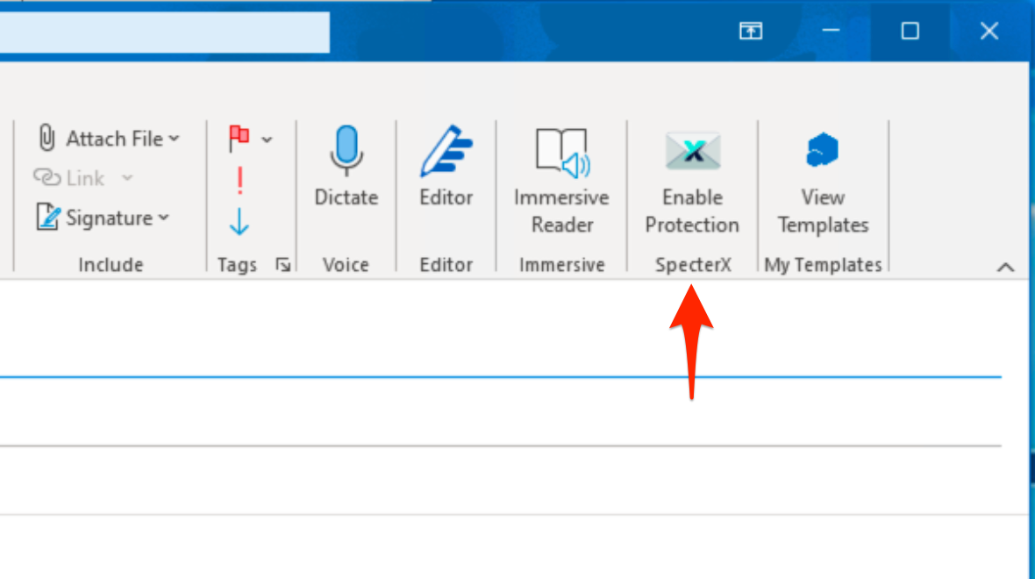
The first user will be defined as part of the onboarding process in the role of an administrator.
The administrator has sign up credentials so before sending the installer to another users, the administrator has to sign up the user through the “Add Members” button in the Users section in SpecterX Web Platform. This way the administrator can control the number of licensed users.

Log in to SpecterX Web Platform
Go to the web address associated with your organization under the SpecterX platform. In most cases, the address will be in this format: {your_company_name}.specterx.com

Access the Users Interface

After logging in to the platform, you can access the interface by clicking the Users button on the home screen. There, you can view all registered users and invite new users to the system using the Add Members button.

Notice!
After the onboarding process, we will suggest uploading the add-in installer to the approved company source, and make it available for other employees.

Technical things to pay attention to in the process of installing in the customer side
- Install the add in only when the Outlook is closed
- Make sure the add in version is the right one for your Office/Outlook (Version, ‎Full build, Channel, ‎32/64-bit)

Issues in accessing protected files from Organizational Workstations
The following information is provided in case an organization you have shared files with through our platform is unable to access those files. In such cases, the issue may be related to network restrictions on the recipient’s side.
When accessing the SpecterX service from organizational computers, successful use of the service requires network access to our internet servers and the cloud infrastructure on which it is hosted.
To ensure proper functionality, the recipient’s workstation browser must be able to communicate with the following addresses:
- *.specterx.com
- s3.eu-central-1.amazonaws.com
- cognito-idp.eu-central-1.amazonaws.com
- cognito-identity.eu-central-1.amazonaws.com
- *.auth.eu-central-1.amazoncognito.com
This list reflects the requirements for viewing the SpecterX Web application, authenticating with the service, and downloading files that have been shared with them.
Blocking access to any of these services may result in pages failing to load or an inability to authenticate (for example, an “Unable to send code. Please try again” message when requesting an OTP, or a “Possible CORS issue” message).

Send Secured Email
Now that the Add-in is installed, you can share files securely.
- Open Outlook and create a new email
- Add your recipients in the To, CC, or BCC fields.
- Attach the files you wish to share.
- Click Enable Protection from the top menu bar.
The SpecterX panel will open on the right-hand side of your window.
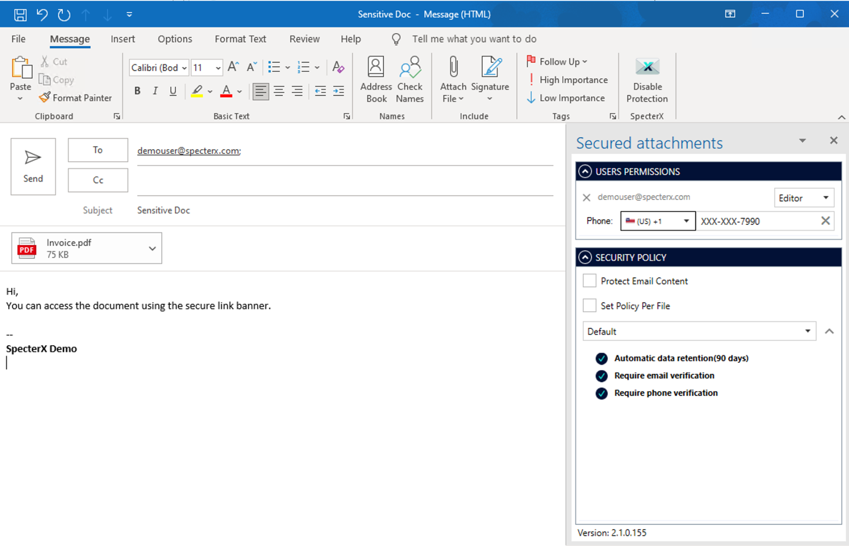

- For each recipient, choose their permission level
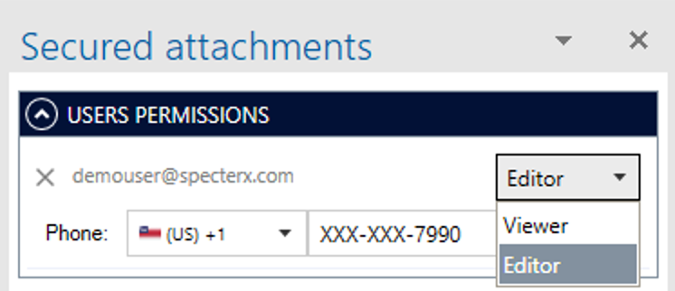

- To also secure the email body and subject line, check Protect Email Content.
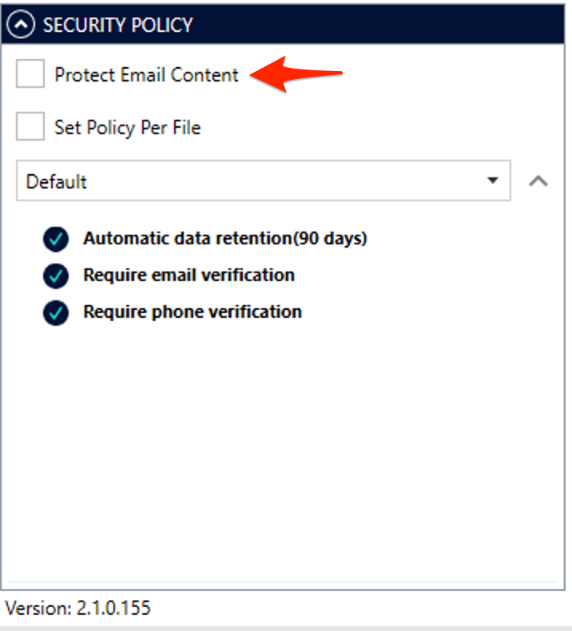

- Select a security policy for your attachments:
  - Choose from the dropdown menu
  - Or, keep the Default policy assigned by your system administrator.
  - You can select one policy for all files or select different policy for each file using the “Set Policy Per File” checkbox
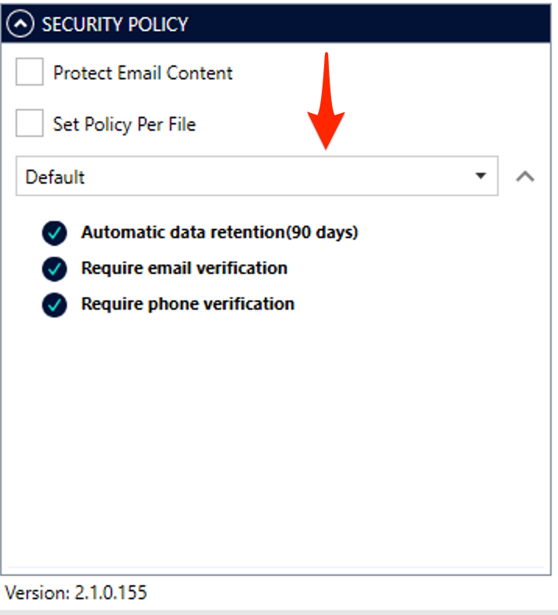

If the chosen policy requires Phone Verification, you’ll be prompted to enter the recipient’s phone number.
This ensures that only verified users can access your secured files.

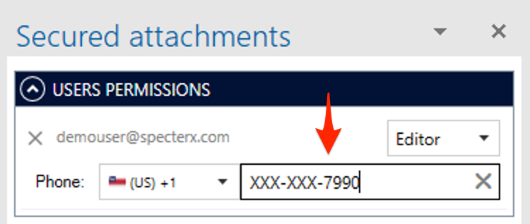

That’s it! Your email and attachments are now fully protected with SpecterX.

Manage File Permissions
After sending a protected email, the SpecterX platform allows you to manage file access permissions efficiently and intuitively. At any time, you can use the SpecterX platform to perform actions such as modifying the protection policy, granting access to new users for an already shared file, blocking access for specific users, and changing each user's permission settings.

Accessing the My Files Interface
After logging in to the platform, you can access the interface by clicking the My Files button on the home screen. There, you can view all the files that have been shared by the user.
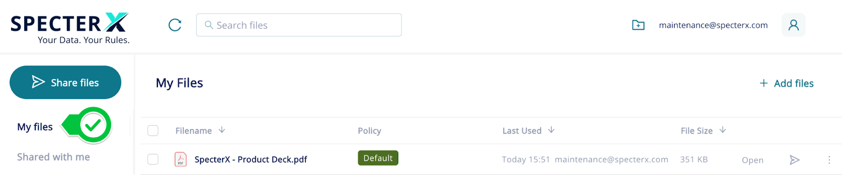

Managing Access Permissions
To access the file’s permission settings, right-click the desired file and select "Security Settings".
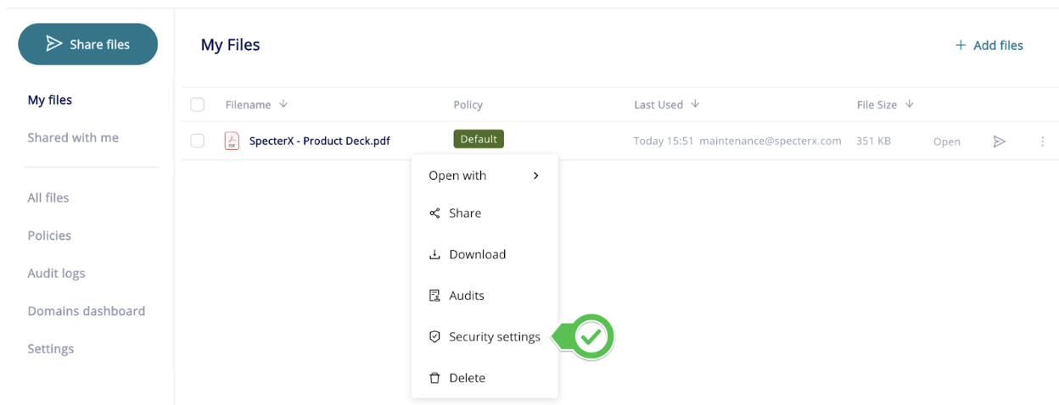

At this stage, a window will open containing two tabs:
Change Policy – Displays the characteristics of the current protection policy and allows you to modify it.
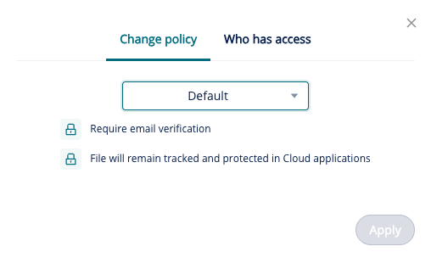
Who Has Access – Displays which users have access to the file and the type of permission assigned to each user: Viewer, Contributor, or Co-owner. In this screen, you can change a user’s permission level or revoke their access to the file by clicking the Revoke button.
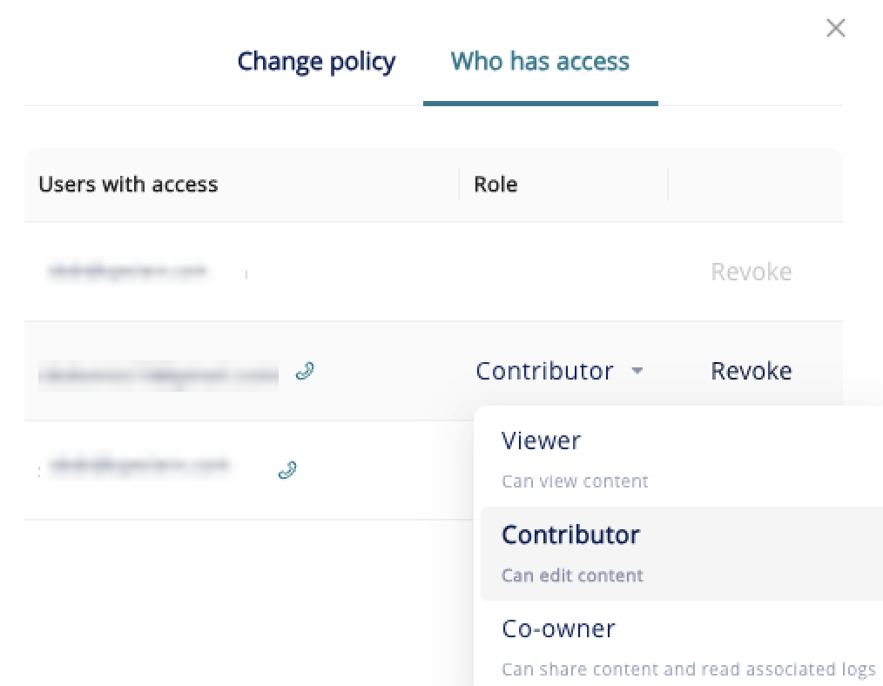

Granting Access to Additional Users
To provide access to additional users for a file that has already been shared, go to the My Files interface and right-click the desired file. In the menu that appears, select "Share".



After clicking "Share", a window will open where you can enter the email addresses of the users you wish to grant access to the file and set the permission type for each user.
You can also copy and send the link to open the file by clicking "Copy" at the bottom of the window.
Note that even when the link is sent manually, only users who have been granted access will be able to open the file.
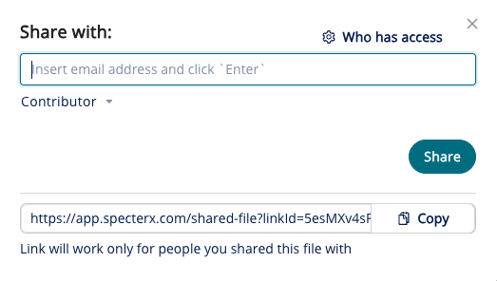

After adding the email address, the "Notify recipients" option will appear in the window. This allows you to send an email notification to the user informing them that they have been granted access to the file.
To complete the process, click the "Share" button.
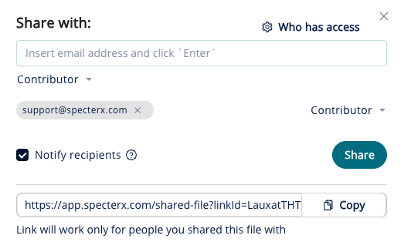

After clicking the "Share" button, the users will be granted access!

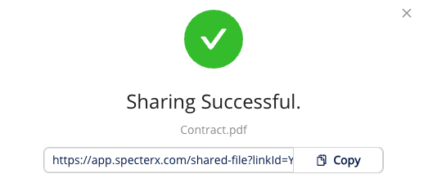

File Management Window
Another way to manage a file’s access permissions is through the File Management window.
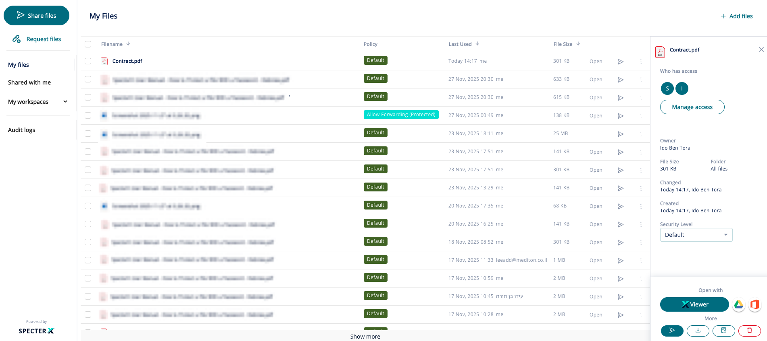
You can access this window from the My Files interface. To open it, click anywhere on the row of the relevant file. After clicking the file row, the File Management window will open on the right side of the screen.

The File Management window is composed of four sections:
- Who Has Access –The top section shows which users have access to the file. Clicking the "Manage Access" button opens the screen where you can modify the protection policy and update access permissions for each user, similar to the "Security Settings" option described earlier in this guide.
- File Details – The middle section of the File Management window contains information about the file and allows you to change the protection policy.
- Open With – The platform offers three ways to open a file: Google Drive, Microsoft Office 365, and SpecterX Viewer.

- More Actions (More) – This section presents four actions related to the file:
• Sharing the file with additional users
• Downloading the file
• Accessing the file’s Audit Logs
• Deleting the file

Admin capabilities:
- admins can specify which policies user can use (can be different from one user to another). the default behaviour of the Add-in is to allow the user to select a policy of his choice from the list of policies he has access to. If needed admins can override the user policy by enforcing Transport rules via the MPS
- How do admins assign policies for outlook connectors?
it's the same setting of the WebUI.
When you select a policy on the Policy pane, you have a setting there to "Allow only specific users to use this policy".
only users defined in the policy list will be able to use it.

if not defined, anyone can use this policy

Connector technological details:

- Outlook connector supported office 2010 and forward
- it works only in the MS outlook app on windows, not on mobile or in outlook web
- File size limits for sharing- based on the Mail infrastructure limitations, usually 25MB
- Supported files- SpecterX can protect all files formats

Other issues:
- Who becomes the data owner for data shared with Outlook connector? - add it to the policy assignment rules section
the user who made the share operation.
once shared via the Add-in, the user can go to the My-Files pane to manage the file as it lives there from now on.

